Always have a cover page for your reports/journals

Module Title: Advanced Digital Design

Module Code: 3801 (if you know it)

Assignment 1:

Title of Assignment

Logos and Images are unnecessary in a cover page. If you include images, they need to be referenced.

Make sure your report layout is A4, margins are Normal (or Narrow if you have large diagrams)

Don’t include student name as DMU prefers that the report be marked without considering student

Student Registration: P123456

Supervisor: Mr. John Doe (or Assessor: or Module Tutor:)

Submission Date: 13th of May 2021 (or Due Date:)

Immediately after the cover page we should find a TOC (Table of Contents), list of Tables and Figures.

**Contents**

1 Introduction 3

1.1 Aims and Objectives 4

1.1.1 Suitable Font Sizes and Line Spacing 5

1.1.2 Headers and Footers and Paragraphs 5

1.1.3 Page borders being outlined 5

1.2 Referencing 6

2 Literature Review or Theory or Methodology or Initial Design Principles 6

3 Design or Product Evaluation and Comparison of Results vs Expectations 7

3.1 Including detailed diagrams 7

3.2 Poor colour choices 9

4 Discussion and or Conclusion 10

References 11

Appendix A 12

**List of Tables**

Table 1 Rainfall Information 10

Table 2 Some random code 12

**List of Figures**

Figure 1 First Level Headings as Small Caps 3

Figure 2 Right Click menu on an Image and the Insert Caption option 4

Figure 3 Outlined Page Border [1] 6

Figure 4 An image with high level of detail and small text 7

Figure 5 Same image as Figure 4 but will be easier for the reader to review 8

Figure 6 Black background and thin colour lines 9

Figure 7 A good image with sensible colour choices 9

# 1 Introduction

As all your reports are Engineering reports; numbered titles (Headings) are preferred like the above. The first level heading can be all caps, but be careful that MS word won’t detect spelling mistakes in all caps. Therefore, you can use “small caps” from the Font menu (Ctrl+D) and tick the circled box similar to the below image.

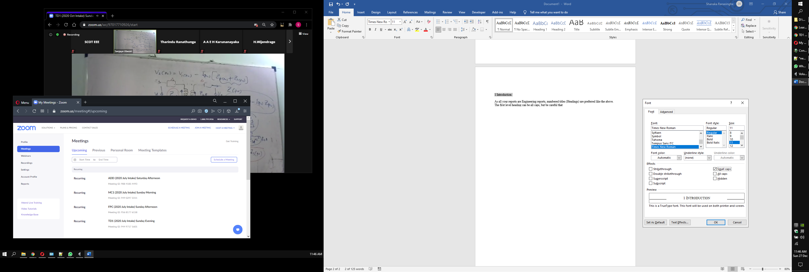

**Figure 1 First Level Headings as Small Caps**

See the “Figure 1First Level Headings as Small Caps” text above (right under the image). That was set by using MS words Caption feature. All you have to do is right click on any image to obtain a menu as shown below and select the circled region. Another great advantage of using insert caption is that MS word will auto number a newly inserted caption even if it is in the middle of the report with other captions after it so that all numbering is sequential. This feature also works with removing an image and caption as well from anywhere in the report.

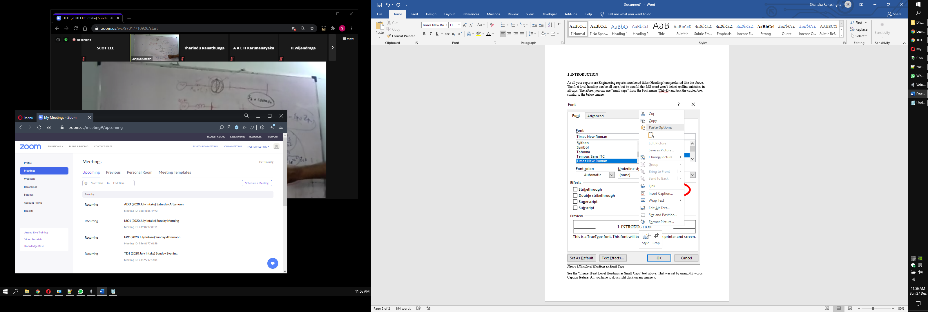

**Figure 2 Right Click menu on an Image and the Insert Caption option**

Now note that the author referred to the images as “the Below image” for Figure 1 in the Introduction. This is bad practice in formal writing. Once you have used captions and properly named your figures, we should always refer to them by Figure number. As an example, we say please refer to Figure 2 instead of please see “the above figure”.

## Aims and Objectives

It’s always good to define your **scope** or **expectations** in the beginning of a report under the introductory section. This can be the **specification** of a design project.

Also note that we have used a new sub topic (second heading) for this paragraph. It is advisable to use up to 3 sub heading levels for a standard report and up to 4 for your thesis. Exceeding this is not good practice for Engineering.

### Suitable Font Sizes and Line Spacing

We have used font 11 for Normal text, Font 14, 12, 11 for Heading Level 1 through 3. This is a good guide for font sizes. Line spacing can remain at 1.15 or single. Don’t use double spacing. If you actually print this report, please use double sided printing as we live in an environmentally conscientious world.

Please remember to justify all your paragraphs and never to use different font size in paragraphs.

### Headers and Footers and Paragraphs

Footers are usually reserved for page numbering. Numbering your pages as XX out of YY is a safe way to ensure that your assessor or supervisor will notice any lost or misplaced pages. However, it will not be useful in your final thesis as you will use section breaks to separate different page numbering formats as it is practice in final dissertations.

You can leave the header blank or have a report title with your P number to ensure any misplaced pages are easily identified as your own and what report it belongs to. You could also get creative and use section breaks to place different headers indicating section headers that matches the main title (Heading 1) in your report to make it easier for the reader to locate sections of your publication.

Note the beginning of this paragraph from the two above. This paragraph has an indented start by using “tab” before the first word of the paragraph after typing in the paragraph. This creates a visually easier way to identify a new paragraph and makes an information rich document more readable. We must cultivate good practices as this while we work towards becoming professionals in our field.

Also note that the different line spacing between sentences within a paragraph and between each paragraph also aid in distinguishing paragraphs and clusters of information easily. In this section the linespacing within the paragraph is single line spacing and the spacing at the end of the paragraph is 6 pt. Do not underestimate the ease of reading for your assessor as the contents may or may not be to his or her liking or expectations.

### Page borders being outlined

This is not suitable for an engineering report or thesis. Please refrain from this. The added disadvantage of outlined page borders as in Figure 3 is that the enclosed content has even less space from the true print border because of the necessary spacing required to pad the text from the indicated border lines.

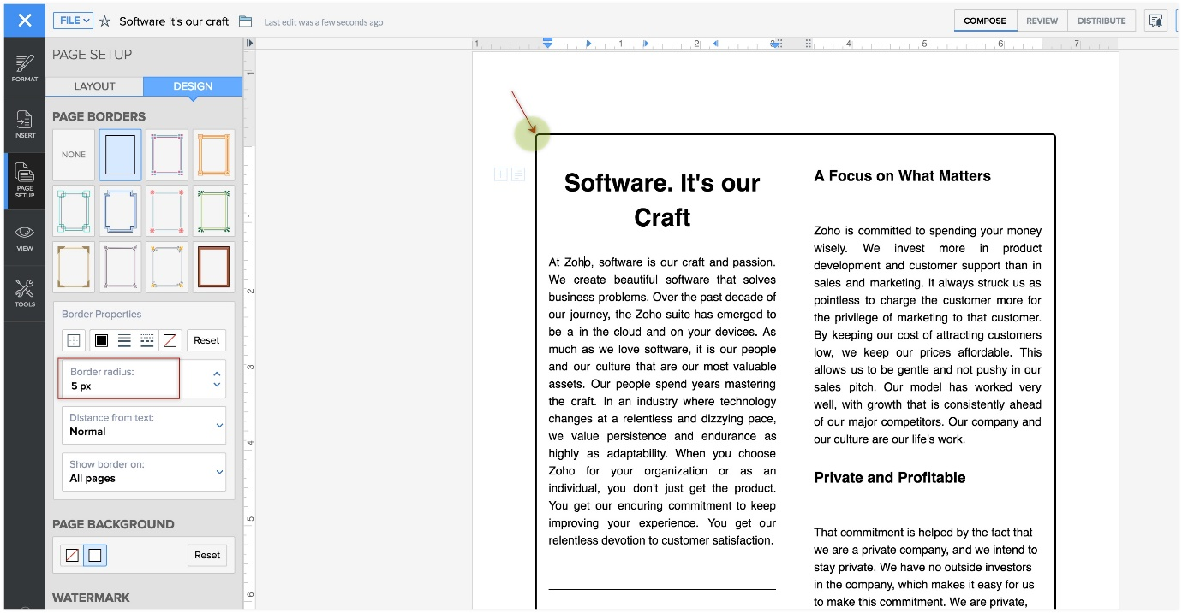

**Figure 3 Outlined Page Border [1]**

Note the superscripted [1] at the end of the Caption of Figure 3. This is essential as this image was not made by the author of this report and therefore needs to be referenced. If you look at item [1] in the References you will find the source location for Figure 3.

## 1.2 Referencing

We will not cover this topic here. Instead, I will refer you to an excellent resource from DMU: <https://www2.library.dmu.ac.uk/DOLORES/19330/referencingpresV2/presentation_html5.html>

Also please read the **Examples of in-text citations** section in the following website: <https://guides.lib.monash.edu/citing-referencing/vancouver-intext>

# 2 Literature Review or Theory or Methodology or Initial Design Principles

This second main topic will be the Literature review of a final year project. It will be a fundamental theory section in a smaller Assignment. Experimental data may not be included in this section depending on the depth of this report as testing and evaluating a design or prototype will usually fall in section 3 of a large project. It is best to seek your Module Tutors advice or follow the instructions given by your supervisor.

# 3 Design or Product Evaluation and Comparison of Results vs Expectations

This section will contain experimental or design data that you will need to evaluate the success of your design or product. You will compare your results with purely theoretical expectations or other product data to see how good your product or design is. If the results don’t match or meet the initial objectives you will need to re-design, further experiment or explain why there are differences.

This is not the section where you fake or manipulate data and results as your DMU Module Leader has seen it all and knows that the data may not need to match or be ideal. This is also the place the Module Leader expects the student to truly show his/her understanding and analytical ability to explain why outcomes match, differ or vary by an acceptable margin.

## 3.1 Including detailed diagrams

Figure 4 has an image with a lot of detail and text. You will frequently have schematics and waveform results with much detail and essential text to discuss about. Including such an image in portrait mode may not be the best option in such cases. If the image can’t be separated to smaller sections, we should at the very least reorient the page so that the image is able to indicate a more details.

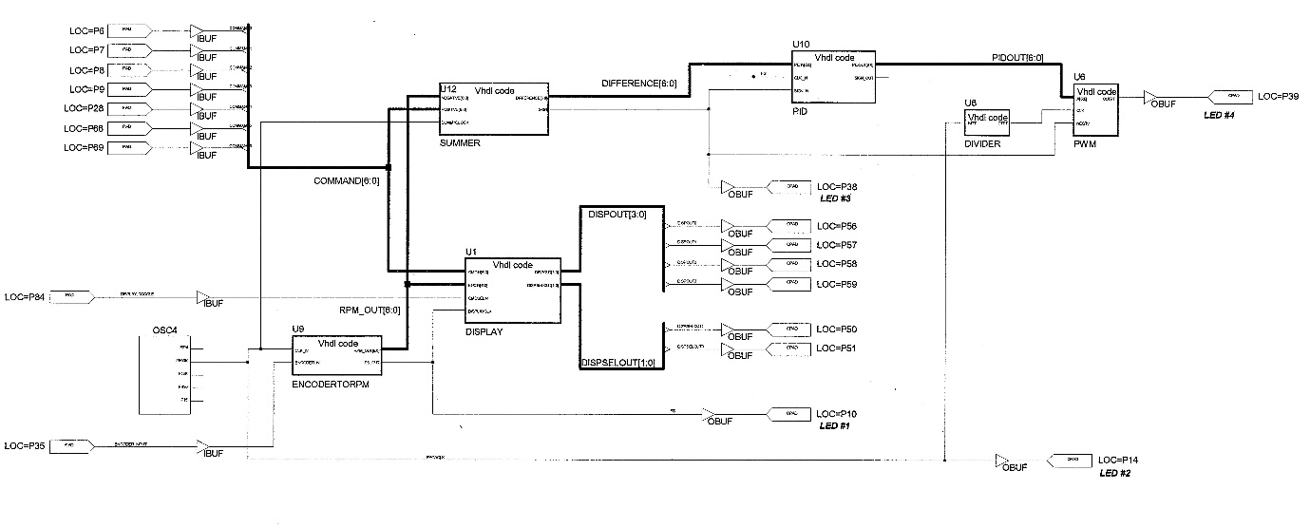

**Figure 4 An image with high level of detail and small text**

If you print this report you will realise the information in the image will be too small to read for most readers and will also depend on the printer quality. To remedy this, we will use a section break and reorient the page to landscape mode to make the image clearer to the reader. Remember you need to use a section break before and after the page you wish to reorient. You can even change the paper type within such a section if reorientation alone does not solve your problem.

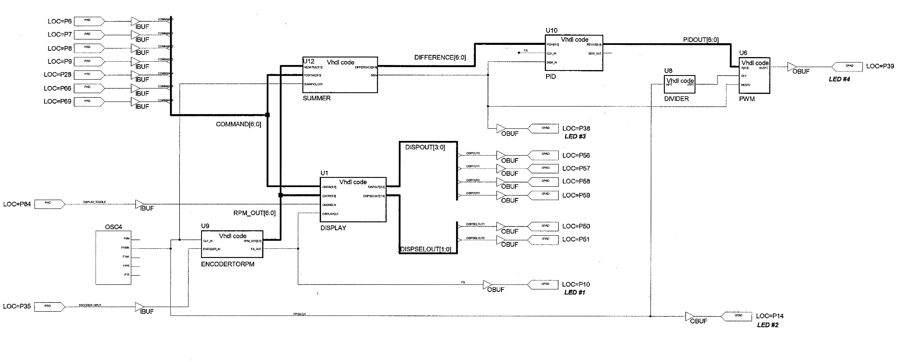

**Figure 5 Same image as Figure 4 but will be easier for the reader to review**

We can agree that Figure 5 is far better for the reader than Figure 4. Including too much paragraphs in a reoriented page like this is not advisable as a reader does not like to read a report in multiple directions. Only include any essential points to note within the image or don’t include reading material at all in such a page. Also note that reoriented paged retain header and footer information but in a reoriented format.

## 3.2 Poor colour choices

Figure 6 is a good example of a bad image. It looks fine on the original digital document and software design platform. However, when you print it, the black background will be overwhelming and the waveforms will be difficult to see clearly. Also, if you refer to the wave forms by colour and print this document in Black and White all your colour related referencing and discussion becomes moot.

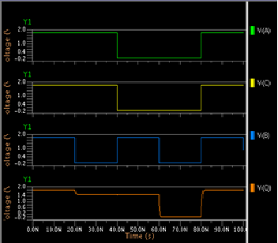

**Figure 6 Black background and thin colour lines**

Sometimes we can have a win-win situation with colour as in Figure 7. The plots are clear in the digital document and can be referenced by shape used to indicate data points. Knowing how to represent data is an invaluable skill.

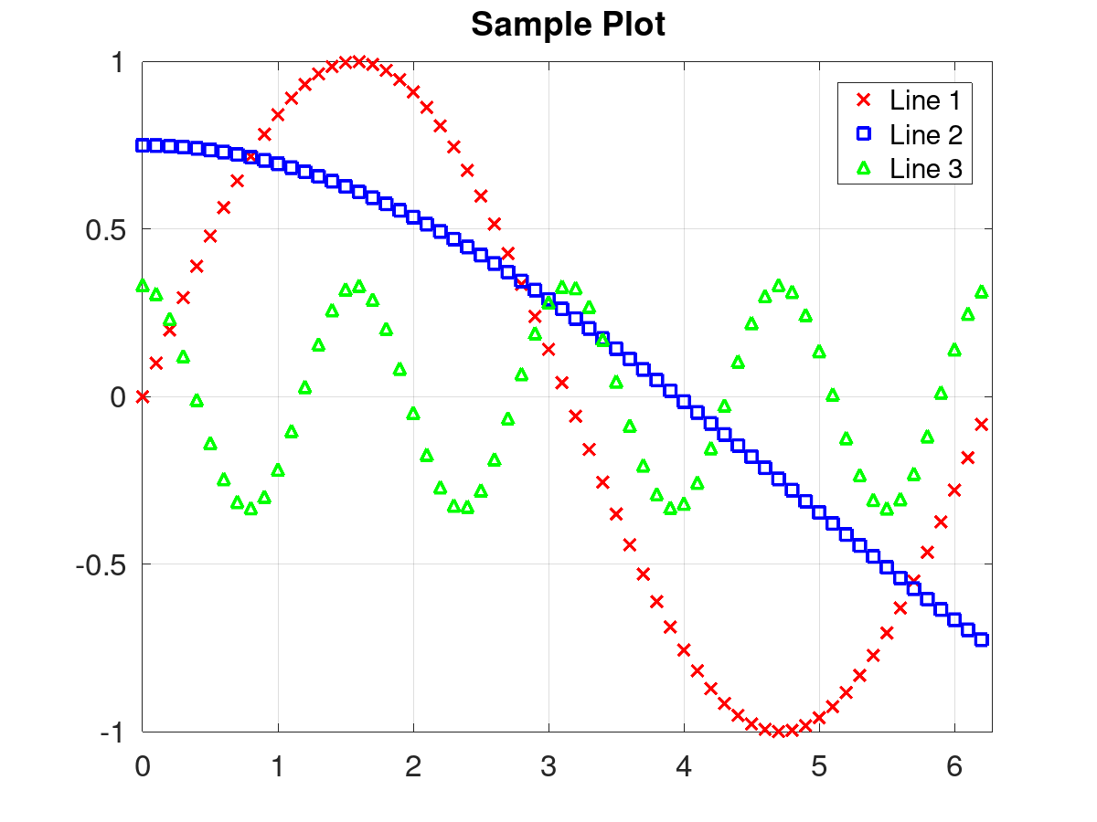

**Figure 7 A good image with sensible colour choices**

# 4 Discussion and or Conclusion

Discussion and Conclusion can be separate parts and it is encouraged to separate them in large projects. The analysis should have been done in the previous section. Introducing new information or data in this section is ill advised.

Table 1 Rainfall Information

| [**Station Number**](http://www.bom.gov.au/watl/rainfall/observations/index.shtml) | [**Station Name**](http://www.bom.gov.au/watl/rainfall/observations/index.shtml) | [**Rainfall (mm)**](http://www.bom.gov.au/watl/rainfall/observations/index.shtml) | [**Mean (mm)**](http://www.bom.gov.au/watl/rainfall/observations/index.shtml) | [**Rank* (percentile)**](http://www.bom.gov.au/watl/rainfall/observations/index.shtml) | **Longitude (°E)** | **Latitude (°S)** | **Elevation (m)** | **No. of years#** |
| --- | --- | --- | --- | --- | --- | --- | --- | --- |
| 61012 | COORANBONG (AVONDALE) | 2.0 | 79.1 | 1.92 | 151.46 | 33.09 | 10 | 105 |
| 61014 | BRANXTON (DALWOOD VINEYARD) | 72.4 | 64.7 | 65.25 | 151.42 | 32.64 | 40 | 119 |
| 61031 | RAYMOND TERRACE (KINROSS) | 70.4 | 72.3 | 57.63 | 151.74 | 32.77 | 10 | 119 |
| 61041 | MORISSET (BALCOLYN (BAY STREET)) | 39.2 | 96.1 | 21.05 | 151.55 | 33.10 | 10 | 20 |
| 61054 | NELSON BAY (NELSON HEAD) | 69.8 | 75.5 | 52.00 | 152.16 | 32.71 | 25 | 101 |
| 61055 | NEWCASTLE NOBBYS SIGNAL STATION AWS | 42.6 | 68.4 | 36.44 | 151.80 | 32.92 | 33 | 119 |
| 61056 | POKOLBIN (BEN EAN) | 65.6 | 64.0 | 58.82 | 151.28 | 32.80 | 140 | 103 |
| 61078 | WILLIAMTOWN RAAF | 58.2 | 81.0 | 38.36 | 151.84 | 32.79 | 9 | 74 |
| 61100 | BROKE (HARROWBY) | 66.4 | 59.5 | 65.42 | 151.09 | 32.77 | 76 | 108 |
| 61110 | HOWES VALLEY | 28.0 | 64.2 | -1.00 | 150.79 | 32.87 | 235 | 16 |
| 61143 | BULGA (DOWN TOWN) | 51.8 | 66.5 | 43.64 | 151.02 | 32.65 | 69 | 56 |
| 61205 | YALLAMBIE (MOUNT AUBAN) | 42.2 | 75.2 | 31.15 | 151.14 | 33.03 | 135 | 62 |
| 61209 | PUTTY TEA ROOMS | 32.6 | 63.0 | 30.00 | 150.68 | 32.96 | 280 | 31 |
| 61211 | COLO HEIGHTS (MOUNTAIN PINES) | 52.4 | 89.2 | 32.76 | 150.71 | 33.36 | 320 | 59 |
| 61216 | LOWER MANGROVE (POPRAN RD) | 40.7 | 87.4 | 18.18 | 151.16 | 33.42 | 10 | 23 |
| 61220 | YARRAMALONG (LEWENSBROOK) | 41.2 | 94.1 | 23.15 | 151.30 | 33.24 | 50 | 55 |
| 61260 | CESSNOCK AIRPORT AWS | 48.0 | 71.6 | 33.33 | 151.34 | 32.79 | 61 | 31 |
| 61268 | MAITLAND BELMORE BRIDGE (HUNTER RIVER) | 52.0 | 86.8 | -1.00 | 151.56 | 32.73 | NA | 13 |
| 61282 | DORA CREEK (DORA ST) | 61.8 | 92.2 | 28.57 | 151.51 | 33.09 | 1 | 29 |
| 61294 | AVOCA BEACH BOWLING CLUB | 36.2 | 97.6 | 16.00 | 151.41 | 33.47 | 8 | 51 |
| 61309 | MILBRODALE (HILLSDALE) | 48.9 | 71.8 | 33.93 | 150.97 | 32.69 | 120 | 57 |
| 61329 | POKOLBIN (JACKSONS HILL) | 45.6 | 73.0 | 33.90 | 151.31 | 32.83 | 125 | 60 |
| 61334 | GLEN ALICE | 36.0 | 60.9 | 30.61 | 150.23 | 33.05 | 320 | 50 |
| 61336 | PUTTY (THE GIBBA) | 1.0 | 57.9 | -1.00 | 150.68 | 33.16 | 330 | 19 |
| 61366 | NORAH HEAD AWS | 51.8 | 89.7 | 32.00 | 151.58 | 33.28 | 19 | 26 |
| 61375 | MANGROVE MOUNTAIN AWS | 60.8 | 95.1 | 24.00 | 151.21 | 33.29 | 305 | 26 |
| 61376 | ERARING (PAYTEN ST) | 40.0 | 92.7 | 14.81 | 151.54 | 33.08 | 5 | 28 |
| 61377 | SWANSEA (CATHERINE ST) | 49.2 | 96.0 | 24.24 | 151.63 | 33.09 | 3 | 34 |
| 61380 | WYONG (JILLIBY (JILLIBY CREEK)) | 19.6 | 89.3 | -1.00 | 151.39 | 33.25 | 15 | 18 |
| 61381 | WYONG (MOUNT ELLIOT) | 50.0 | 105.0 | 31.58 | 151.39 | 33.40 | 165 | 20 |
| 61382 | WYONG (KULNURA (JEAVONS)) | 51.0 | 90.0 | -1.00 | 151.22 | 33.17 | 270 | 19 |
| 61383 | GEARS (WYONG RIVER) | 19.0 | 83.0 | -1.00 | 151.32 | 33.25 | 20 | 19 |
| 61385 | WYONG (OLNEY FOREST) | 44.0 | 95.7 | 15.79 | 151.34 | 33.08 | 390 | 20 |
| 61387 | GOROKAN (GOOBARABAH ST) | 46.2 | 91.9 | 25.00 | 151.51 | 33.25 | 12 | 25 |
| 61390 | NEWCASTLE UNIVERSITY | 40.0 | 102.2 | 9.52 | 151.71 | 32.89 | 21 | 22 |
| 61394 | KULNURA (MANGROVE CREEK DAM) | 43.0 | 85.5 | 28.95 | 151.13 | 33.22 | 220 | 39 |

This is not a proper section to include a Table of (raw data) information. We just included this table to show that Table names must also be captioned just like images. Also note that this table spans more than one page. Therefore, you should repeat the table heading information using “Header Row” feature MS word Table Tools >> Design settings because the reader will not be able to keep track of column information in a page where the table heading is missing.

The following setciton is intentionally copy/pasted from a reference book:

The E2PROM transistor is similar to an EPROM transistor in that it contains a floating gate, but the insulating oxide layers surrounding this gate are very much thinner. The second transistor can be used to erase the cell electrically. E2PROMs first saw the light of day as computer memories, but the same technology was eventually applied to PLDs, which became known as electrically erasable PLDs (EEPLDs or E2PLDs). FLASH can trace its ancestry to both EPROM and EEPROM technologies.[2] pg.11

Firstly, don’t ever copy paste text from any source. Secondly, this was done only to give a second in-text referencing example as you should notice at the end of the above paragraph.

# References

[1] Zoho Content Writer, *Page Design*, Available at: https://www.zoho.com/writer/help/page-design.html (Accessed: 27 December 2020).

[2] Maxfield, C, (1957) *FPGAs: Instant Access*, The Newnes instant access series

All references should be numbered and intext numbering must be used in your report!

# 

# Appendix A

Things like programme code can be very long and we only extract relevant sections during discussions. However, you are frequently expected to submit all your code with your report and the Appendix is the best place to insert things like large data tables and full programme code. You can place code in a single cell table and caption it appropriately.

**Table 2 Some random code**

|  |
| --- |
| **library** ieee;  **use** ieee.std_logic_1164.all;  **package**basic_func **is**  **--** AND2 declaration  **component** AND2  **generic** (DELAY: time :=5ns);  **port** (in1, in2: **in** std_logic; out1: **out** std_logic);  **end component;**  **--** OR2 declaration  **component** OR2  **generic** (DELAY: time :=5ns);  **port** (in1, in2: **in** std_logic; out1: **out** std_logic);  **end component;**  **end package**basic_func;    -- Package body declarations  **library** ieee;  **use** ieee.std_logic_1164.all;  **package body** basic_func **is**       -- 2 input AND gate      **entity** AND2 **is**  **generic**(DELAY: time);  **port** (in1, in2: **in** std_logic; out1: **out** std_logic);  **end** AND2;  **architecture** model_conc **of** AND2 **is**  **begin**                  out1 <= in1 **and** in2 **after** DELAY;  **end** model_conc;  -- 2 input OR gate **entity** OR2 **is**  **generic**(DELAY: time);  **port** (in1, in2: **in** std_logic; out1: **out** std_logic);  **end** OR2;  **architecture** model_conc2 **of** AND2 **is**  **begin**                  out1 <= in1 **or** in2 **after** DELAY;  **end** model_conc2;  **end package body**basic_func; |